PROJECT NAME:

RYANA CALENDARS

PRESENTED AT



TEAM MEMBERS:

IZHAR KARIM, ABDUL WAHAB, SYED AMAL, LUBNA KHALID

INSTRUCTOR:

SIR ASAD

Table of contents

1. Acknowledgement
2. Problem Statement
3. About Project
4. Website Screen Shots
5. Guide

ACKNOWLEDGEMENT

I would like to acknowledge all those who have given me moral support and helped in making the project a success.

I wish to express my gratitude to e Project Team at Head Office who guided and helped me. Also, I would like to express my gratitude to all the staff members of my center for not only providing me opportunity to work with them on this project, but also for their support and encouragement throughout the process.

I also express my sincere gratitude to e Project Team from Aptech Head Office and my project guide at the organization for its valuable guidance and support for completion of this project.

PROBLEM STATEMENT

Ryana Calendars is selling various Calendars and Diary products. The company advertises by distributing the pamphlets, advertising on television and so on. Due to rapid development in internet field, the company decides to launch a website where people will get all the information about the various products available with them easily.

Requirements

* The Home Page should be created making use of Sections with a suitable logo
* The site should display a menu which will contain the options for brief introduction about the various products available, location of the shop and any other information if required.
* The information should be categorized according to different type of products like if a User wants to see only ‘Journal’ then he click on a Link/button/menu etc. and he will see different type of Journal. Similarly for ‘Calendars’, ‘Diaries’ and other products

* When a user selects any product type, a list of products for that product type will be displayed.
* A brief summary of features of individual products should be displayed on the Web Page along with the product but detailed Features should be stored in Individual Word documents which can be downloaded or viewed by the User who wishes to see the same.
* Price List should be available for download.
* There should be a “Contact Us” page which will have the Address of the Company which is as follows and the mail address which when clicked will invoke the local mail client from where they can send an email.

ABOUT PROJECT

Software

Adobe illustrator (website logo), MS Word

Compiler

Visual studio code

Website developed on

HTML5, CSS3, Bootstrap, JQuery, Font Awesome

Operating System

Windows

SCREENSHOTS

HOMEPAGE

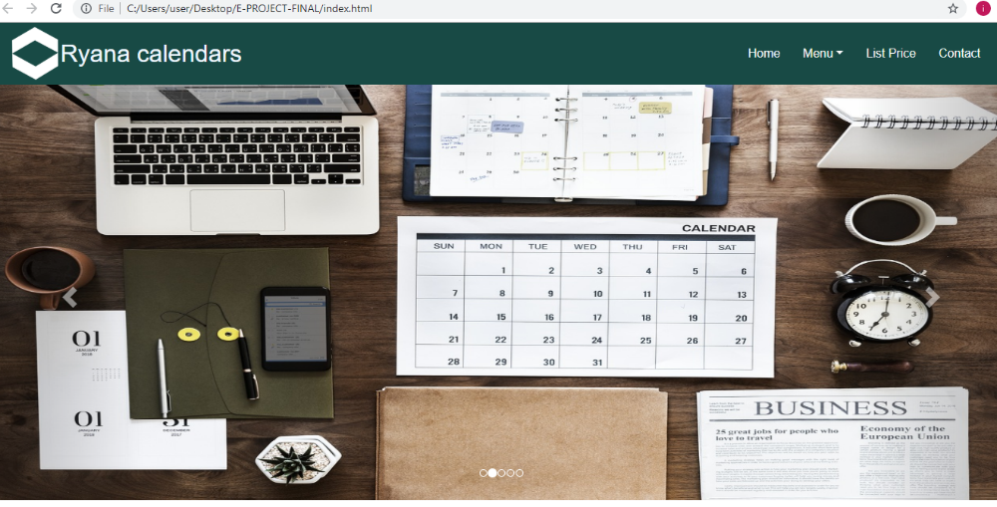

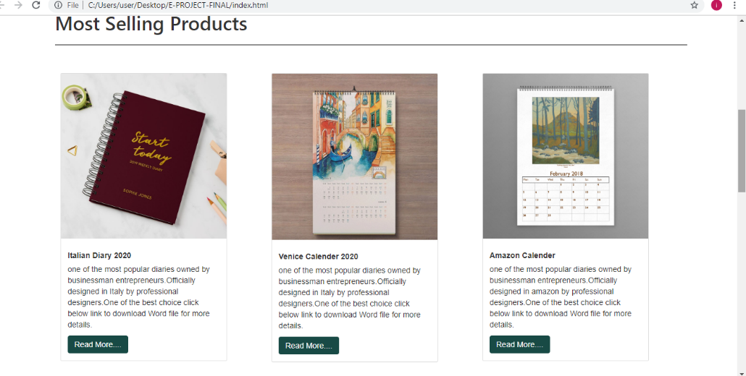

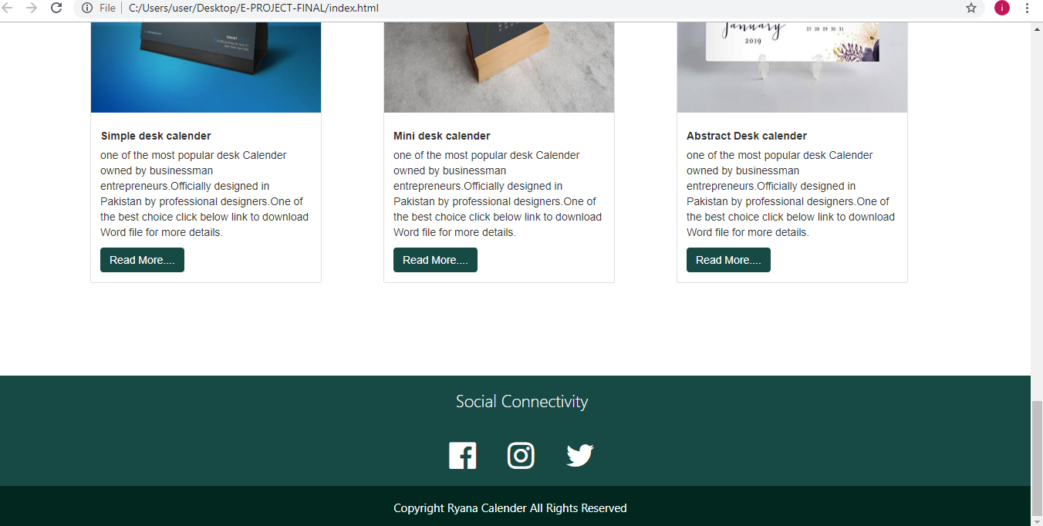

MENU

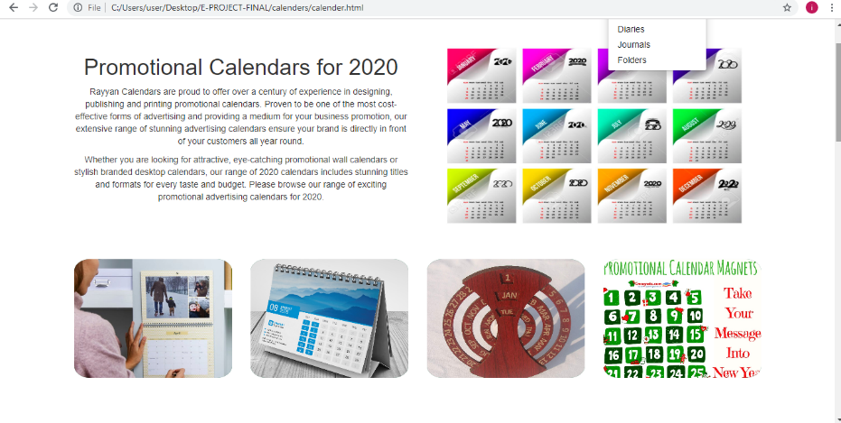

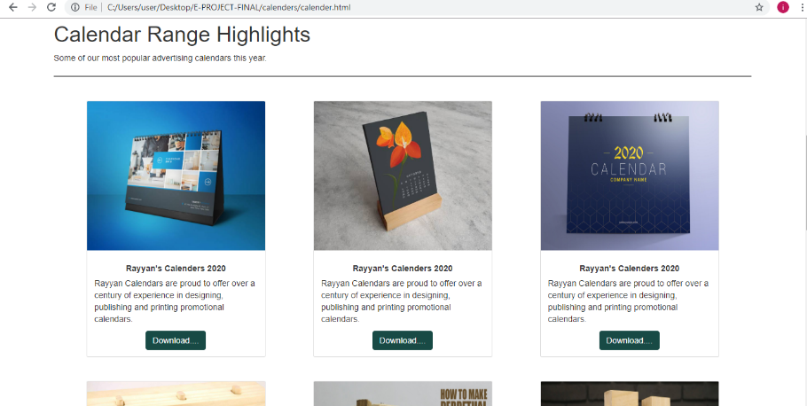

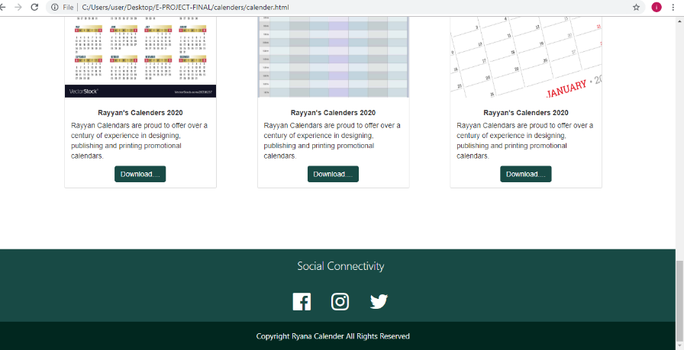

LIST PRICE

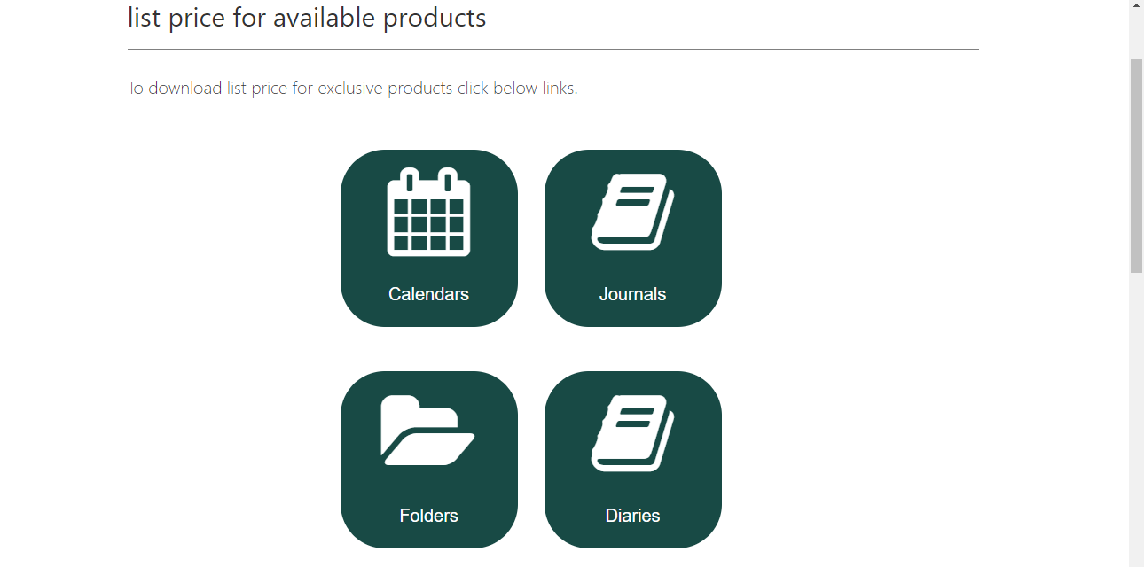

CONTACT US

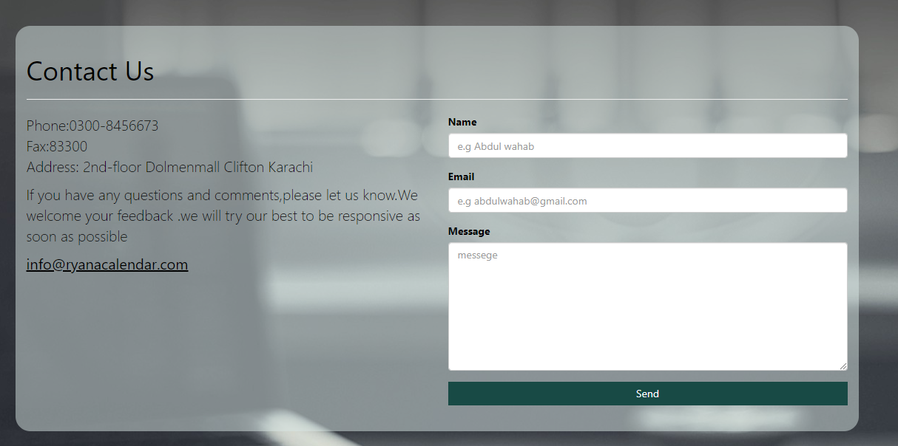

GUIDE

The site RYANA CALENDARS is developed with 4 sections .i.e Home, Menu, List Price and Contact Us.The Home page consist of slider which can be used to display offers or any news related to any product. Below that a show case of best selling products is displayed so that user can easily access to best products. furthermore a footer displays 3 icons of social media which directs the user to its social media page. Secondly the Menu section is subdivided into Calendars, Diaries, Journals and Folders. Each page is further subdivided, according to its categories like user clicks on calendar then he/she can see categories related to that product .i.e wooden calendar, desk calendar, organizer etc. Similary to display price of available products user can click on Price List section. From there they can be informed about price of different products through word file.To further assist the user location of the shop is also displayed via Google maps. If user is wants to ask anything related to any product then he/she can click on Contact Us.Which has the address,fax,phone number and email which when click invoke local mail client from where they can send an email.

THANK YOU.